ROAD TRAFFIC REGULATION ACT 1984 – SECTION 14(2)

Temporary Closure of Footpath 32, Henham

NOTICE IS HEREBY GIVEN that from the date specified below, the Essex County Council has temporarily closed to all traffic under Section 14(2) of the Road Traffic Regulation Act 1984, as amended, Footpath 32, Henham in the District of Uttlesford, approximately 10 metres either side of Elsenham Emergency Hut Network Rail Crossing.
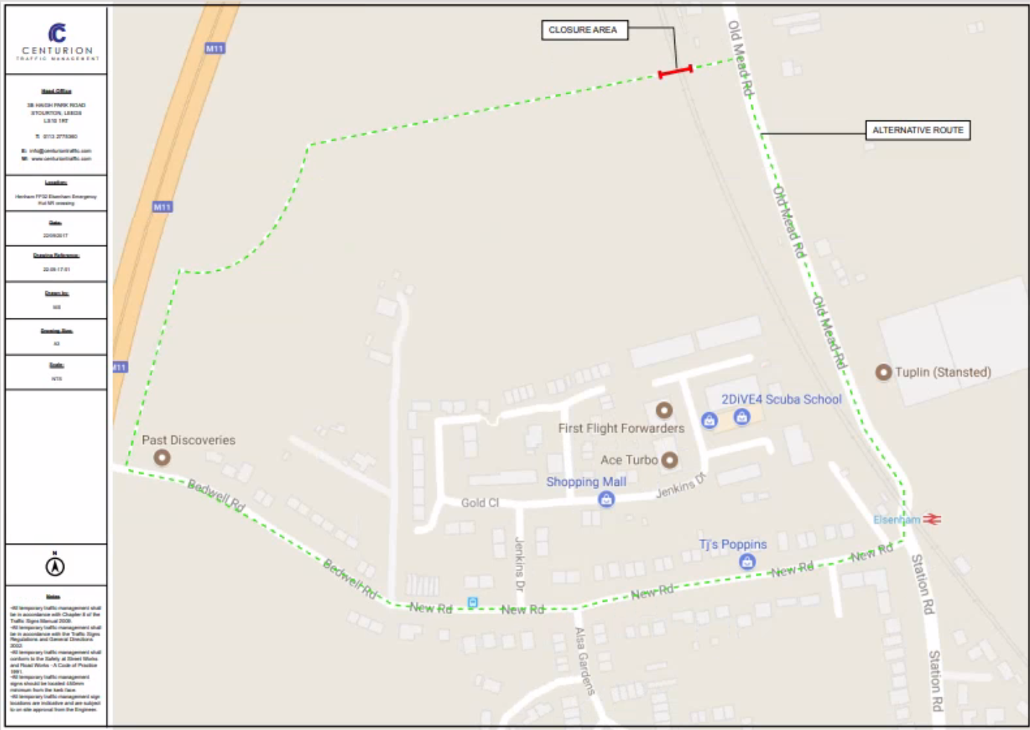
The closure is scheduled to take place on 10 April 2024 for 21 days and is required for the safety of the public due to insufficient sighting for pedestrians to cross the foot crossing safely and the presence of high-speed trains.

The alternative route will be via Footpath 14 Ugley, Bedwell Road, New Road, Old Mead Road.

ESSEX COUNTY COUNCIL
COUNTY HALL
CHELMSFORD, ESSEX

CM1 1QH

TEL: 0345 603 7631
DATE: 19 April 2024

